---- Non-linear least squares estimation of ARFIMA(1,0,0) model ----
The estimation sample is: 1995 (7) - 2004 (1)
The dependent variable is: LEMBI+ BZ JPM2 (AZ REG1.xls)

Coefficient Std.Error t-value t-prob
AR-1 0.931394 0.03693 25.2 0.000
Constant -3.38515 0.2116 -16.0 0.000
RSK AVRS ii 0.00462083 0.001053 4.39 0.000

log-likelihood 82.1800814
no. of observations 103 no. of parameters 4
AIC.T -156.360163 AIC -1.51805983
mean(LEMBI+ BZ JPM2) -2.66166 var(LEMBI+ BZ JPM2) 0.128094
sigma 0.11003 sigma^2 0.0121067

BFGS using numerical derivatives (eps1=0.0001; eps2=0.005):
Strong convergence
Used starting values:
0.87668 -3.8713 0.0092251

Portmanteau statistic for residuals
Autocorrelation function (ACF) from lag 1 to 36:
0.17635 0.046799 0.0085248 0.070799 -0.0010942 -0.069647
0.095629 0.038878 0.039208 -0.00052316 -0.018098 0.039628
0.086443 -0.0049629 -0.18088 -0.15177 -0.13182 -0.18754
-0.10393 0.021777 0.0077224 -0.064553 -0.097996 -0.097347
-0.060859 0.012135 0.064225 -0.085665 -0.063333 0.0076689
-0.081097 -0.14688 0.097270 0.11300 0.017983 0.027997
Partial autocorrelation function (PACF):
0.17635 0.016204 -0.0025315 0.071221 -0.026343 -0.071958
0.12684 -0.00052645 0.025894 0.00049799 -0.039299 0.045775
0.092739 -0.052215 -0.18425 -0.10726 -0.10376 -0.14490
-0.019129 0.043315 -0.026619 -0.035920 -0.063470 -0.075356
-0.0040706 0.056709 0.088144 -0.077375 -0.030888 0.025535
-0.10235 -0.16025 0.092104 -0.0047019 -0.027616 0.064761
Portmanteau(36): Chi^2(35)= 35.294 [0.4543]

Normality test for residuals
Observations 103
Mean 4.4971e-005
Std.Devn. 0.10896
Skewness 1.0239
Excess Kurtosis 2.3258
Minimum -0.24694
Maximum 0.44240
Asymptotic test: Chi^2(2) = 41.212 [0.0000]**
Normality test: Chi^2(2) = 14.979 [0.0006]**

ARCH coefficients:
Lag Coefficient Std.Error
1 0.063746 0.1007
RSS = 0.0624211 sigma = 0.0252379

Testing for error ARCH from lags 1 to 1
ARCH 1-1 test: F(1,98) = 0.40075 [0.5282]

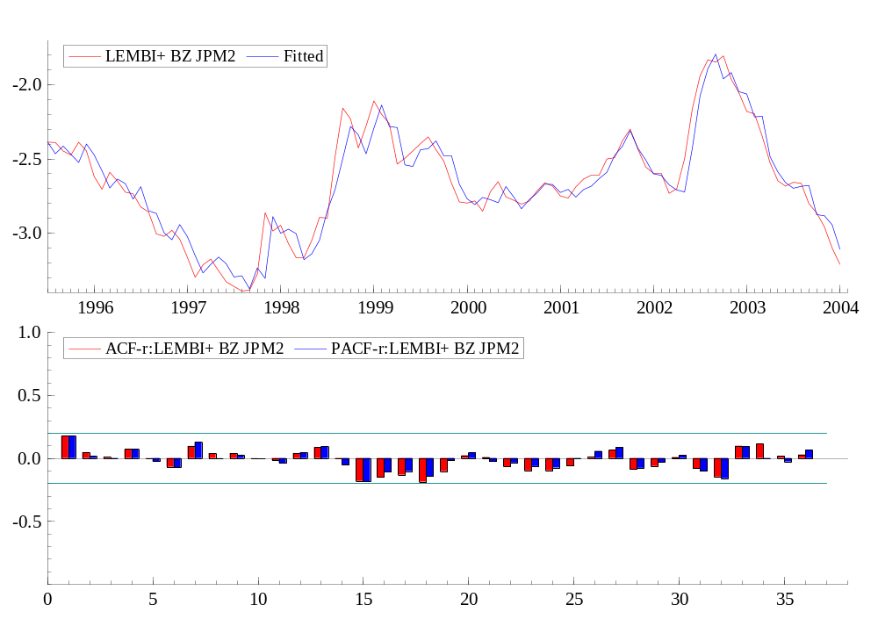

---- Non-linear least squares estimation of ARFIMA(1,0,0) model ----
The estimation sample is: 1999 (2) - 2004 (1)
The dependent variable is: LEMBI+ BZ JPM2 (AZ REG1.xls)

Coefficient Std.Error t-value t-prob
AR-1 0.920051 0.05730 16.1 0.000
Constant -3.48556 0.2237 -15.6 0.000
RSK AVRS ii 0.00532983 0.001133 4.71 0.000

log-likelihood 59.9971377
no. of observations 60 no. of parameters 4
AIC.T -111.994275 AIC -1.86657126
mean(LEMBI+ BZ JPM2) -2.53865 var(LEMBI+ BZ JPM2) 0.0879649
sigma 0.0905422 sigma^2 0.00819788

BFGS using numerical derivatives (eps1=0.0001; eps2=0.005):
Strong convergence
Used starting values:
0.78133 -3.9715 0.0099640

---- Non-linear least squares estimation of ARFIMA(1,0,0) model ----
The estimation sample is: 1995 (7) - 2002 (2)
The dependent variable is: LEMBI+ BZ JPM2 (AZ REG1.xls)

Coefficient Std.Error t-value t-prob
AR-1 0.917936 0.04098 22.4 0.000
Constant -3.21521 0.2233 -14.4 0.000
RSK AVRS ii 0.00349616 0.001276 2.74 0.008

log-likelihood 64.2413096
no. of observations 80 no. of parameters 4
AIC.T -120.482619 AIC -1.50603274
mean(LEMBI+ BZ JPM2) -2.72248 var(LEMBI+ BZ JPM2) 0.0991292
sigma 0.109778 sigma^2 0.0120512

BFGS using numerical derivatives (eps1=0.0001; eps2=0.005):
Strong convergence
Used starting values:
0.90737 -3.4734 0.0059907

---- Non-linear least squares estimation of ARFIMA(1,0,0) model ----
The estimation sample is: 1999 (2) - 2002 (2)
The dependent variable is: LEMBI+ BZ JPM2 (AZ REG1.xls)

Coefficient Std.Error t-value t-prob
AR-1 0.813274 0.06790 12.0 0.000
Constant -3.11308 0.1970 -15.8 0.000
RSK AVRS ii 0.00327318 0.001309 2.50 0.018

log-likelihood 45.3634552
no. of observations 37 no. of parameters 4
AIC.T -82.7269105 AIC -2.23586245
mean(LEMBI+ BZ JPM2) -2.59368 var(LEMBI+ BZ JPM2) 0.0283093
sigma 0.0730076 sigma^2 0.00533012

BFGS using numerical derivatives (eps1=0.0001; eps2=0.005):
Strong convergence
Used starting values:
0.80221 -2.6706 0.00055245

---- Non-linear least squares estimation of ARFIMA(1,0,0) model ----
The estimation sample is: 1995 (7) - 2005 (11)
The dependent variable is: LEMBI+ BZ JPM2 (AZ REG1.xls)

Coefficient Std.Error t-value t-prob
AR-1 0.942487 0.03170 29.7 0.000
Constant -3.45287 0.2092 -16.5 0.000
RSK AVRS ii 0.00453221 0.0009865 4.59 0.000

log-likelihood 104.234368
no. of observations 125 no. of parameters 4
AIC.T -200.468736 AIC -1.60374989
mean(LEMBI+ BZ JPM2) -2.7465 var(LEMBI+ BZ JPM2) 0.14552
sigma 0.105954 sigma^2 0.0112263

BFGS using numerical derivatives (eps1=0.0001; eps2=0.005):
Strong convergence
Used starting values:
0.86219 -4.0767 0.010617

---- Non-linear least squares estimation of ARFIMA(1,0,0) model ----
The estimation sample is: 1999 (2) - 2005 (11)
The dependent variable is: LEMBI+ BZ JPM2 (AZ REG1.xls)

Coefficient Std.Error t-value t-prob
AR-1 0.945816 0.03930 24.1 0.000
Constant -3.59710 0.2550 -14.1 0.000
RSK AVRS ii 0.00503408 0.001052 4.79 0.000

log-likelihood 83.1243388
no. of observations 82 no. of parameters 4
AIC.T -158.248678 AIC -1.92986192
mean(LEMBI+ BZ JPM2) -2.70098 var(LEMBI+ BZ JPM2) 0.145795
sigma 0.0888946 sigma^2 0.00790226

BFGS using numerical derivatives (eps1=0.0001; eps2=0.005):
Strong convergence
Used starting values:
0.75946 -4.2496 0.011776

---- Non-linear least squares estimation of ARFIMA(1,0,0) model ----
The estimation sample is: 1999 (7) - 2005 (11)
The dependent variable is: LEMBI+ BZ JPM2 (AZ REG1.xls)

Coefficient Std.Error t-value t-prob
AR-1 0.957736 0.04055 23.6 0.000
Constant -3.65917 0.3414 -10.7 0.000
RSK AVRS ii 0.00509796 0.001021 4.99 0.000

log-likelihood 80.7778489
no. of observations 77 no. of parameters 4
AIC.T -153.555698 AIC -1.99422984
mean(LEMBI+ BZ JPM2) -2.72136 var(LEMBI+ BZ JPM2) 0.147313
sigma 0.0858767 sigma^2 0.00737481

BFGS using numerical derivatives (eps1=0.0001; eps2=0.005):
Strong convergence
Used starting values:
0.70573 -4.3069 0.012014

---- Non-linear least squares estimation of ARFIMA(1,0,0) model ----
The estimation sample is: 2003 (3) - 2005 (11)
The dependent variable is: LEMBI+ BZ JPM2 (AZ REG1.xls)

Coefficient Std.Error t-value t-prob
AR-1 0.901825 0.06581 13.7 0.000
Constant -3.62801 0.3037 -11.9 0.000
RSK AVRS ii 0.00331899 0.002223 1.49 0.146

log-likelihood 38.0893904
no. of observations 33 no. of parameters 4
AIC.T -68.1787809 AIC -2.06602366
mean(LEMBI+ BZ JPM2) -3.01865 var(LEMBI+ BZ JPM2) 0.0742519
sigma 0.0787165 sigma^2 0.00619629

BFGS using numerical derivatives (eps1=0.0001; eps2=0.005):
Strong convergence
Used starting values:
0.66687 -4.2727 0.011452

---- Non-linear least squares estimation of ARFIMA(1,0,0) model ----
The estimation sample is: 2003 (10) - 2005 (11)
The dependent variable is: LEMBI+ BZ JPM2 (AZ REG1.xls)

Coefficient Std.Error t-value t-prob
AR-1 0.892464 0.1008 8.85 0.000
Constant -3.60879 0.3583 -10.1 0.000
RSK AVRS ii 0.00304368 0.003133 0.971 0.342

log-likelihood 28.2763752
no. of observations 26 no. of parameters 4
AIC.T -48.5527504 AIC -1.86741348
mean(LEMBI+ BZ JPM2) -3.12667 var(LEMBI+ BZ JPM2) 0.0344583
sigma 0.084884 sigma^2 0.00720529

BFGS using numerical derivatives (eps1=0.0001; eps2=0.005):
Strong convergence
Used starting values:
0.66851 -4.5502 0.014229
AZ REG1 men 3.xls loaded from C:\TESES MESTRADO\emetricsmarch2004\MODELO 1 Default X Risk Aversion\Extensão de prazo e INPUT NOVO\AZ REG1 men 3.xls

---- Non-linear least squares estimation of ARFIMA(1,0,0) model ----
The estimation sample is: 1995 (7) - 2002 (12)
The dependent variable is: LEMBI+ BZ JPM2 (AZ REG1 men 3.xls)

Coefficient Std.Error t-value t-prob
AR-1 0.923718 0.04060 22.8 0.000
Constant -3.23497 0.2249 -14.4 0.000
RSK AVRS ii 0.00301313 0.001293 2.33 0.022

log-likelihood 72.2443164
no. of observations 90 no. of parameters 4
AIC.T -136.488633 AIC -1.51654037
mean(LEMBI+ BZ JPM2) -2.74138 var(LEMBI+ BZ JPM2) 0.0898139
sigma 0.109655 sigma^2 0.0120242

BFGS using numerical derivatives (eps1=0.0001; eps2=0.005):
Strong convergence
Used starting values:
0.89084 -3.4976 0.0060901

---- Non-linear least squares estimation of ARFIMA(1,0,0) model ----
The estimation sample is: 1999 (2) - 2002 (12)
The dependent variable is: LEMBI+ BZ JPM2 (AZ REG1 men 3.xls)

Coefficient Std.Error t-value t-prob
AR-1 0.886371 0.07201 12.3 0.000
Constant -3.15201 0.2312 -13.6 0.000
RSK AVRS ii 0.00240617 0.001537 1.57 0.125

log-likelihood 51.3891054
no. of observations 47 no. of parameters 4
AIC.T -94.7782108 AIC -2.01655768
mean(LEMBI+ BZ JPM2) -2.65728 var(LEMBI+ BZ JPM2) 0.0350323
sigma 0.0828618 sigma^2 0.00686608

BFGS using numerical derivatives (eps1=0.0001; eps2=0.005):
Strong convergence
Used starting values:
0.75077 -3.0930 0.0032521

---- Non-linear least squares estimation of ARFIMA(1,0,0) model ----
The estimation sample is: 1995 (7) - 2004 (10)
The dependent variable is: LEMBI+ BZ JPM2 (AZ REG1 men 3.xls)

Coefficient Std.Error t-value t-prob
AR-1 0.937719 0.03416 27.4 0.000
Constant -3.32692 0.2174 -15.3 0.000
RSK AVRS ii 0.00304703 0.001186 2.57 0.012

log-likelihood 94.4129544
no. of observations 112 no. of parameters 4
AIC.T -180.825909 AIC -1.61451704
mean(LEMBI+ BZ JPM2) -2.82041 var(LEMBI+ BZ JPM2) 0.104721
sigma 0.105094 sigma^2 0.0110447

BFGS using numerical derivatives (eps1=0.0001; eps2=0.005):
Strong convergence
Used starting values:
0.87197 -3.9468 0.0094633

---- Non-linear least squares estimation of ARFIMA(1,0,0) model ----
The estimation sample is: 1999 (2) - 2004 (10)
The dependent variable is: LEMBI+ BZ JPM2 (AZ REG1 men 3.xls)

Coefficient Std.Error t-value t-prob
AR-1 0.939664 0.04115 22.8 0.000
Constant -3.37627 0.2659 -12.7 0.000
RSK AVRS ii 0.00238277 0.001397 1.71 0.093

log-likelihood 74.641325
no. of observations 69 no. of parameters 4
AIC.T -141.28265 AIC -2.04757464
mean(LEMBI+ BZ JPM2) -2.81237 var(LEMBI+ BZ JPM2) 0.0866128
sigma 0.0832431 sigma^2 0.00692942

BFGS using numerical derivatives (eps1=0.0001; eps2=0.005):
Strong convergence
Used starting values:
0.76214 -4.2064 0.011378

---- Non-linear least squares estimation of ARFIMA(1,0,0) model ----
The estimation sample is: 2002 (2) - 2004 (10)
The dependent variable is: LEMBI+ BZ JPM2 (AZ REG1 men 3.xls)

Coefficient Std.Error t-value t-prob
AR-1 0.905797 0.06371 14.2 0.000
Constant -3.55764 0.2703 -13.2 0.000
RSK AVRS ii 0.00243513 0.001960 1.24 0.224

log-likelihood 38.1174342
no. of observations 33 no. of parameters 4
AIC.T -68.2348684 AIC -2.06772329
mean(LEMBI+ BZ JPM2) -3.02322 var(LEMBI+ BZ JPM2) 0.0687824
sigma 0.0786497 sigma^2 0.00618577

BFGS using numerical derivatives (eps1=0.0001; eps2=0.005):
Strong convergence
Used starting values:
0.55011 -4.4171 0.012909

---- Non-linear least squares estimation of ARFIMA(1,0,0) model ----
The estimation sample is: 2002 (10) - 2004 (10)
The dependent variable is: LEMBI+ BZ JPM2 (AZ REG1 men 3.xls)

Coefficient Std.Error t-value t-prob
AR-1 0.906812 0.1057 8.58 0.000
Constant -3.60296 0.3883 -9.28 0.000
RSK AVRS ii 0.00286899 0.003179 0.902 0.377

log-likelihood 26.8230949
no. of observations 25 no. of parameters 4
AIC.T -45.6461899 AIC -1.82584759
mean(LEMBI+ BZ JPM2) -3.13721 var(LEMBI+ BZ JPM2) 0.0329469
sigma 0.0862788 sigma^2 0.00744403

BFGS using numerical derivatives (eps1=0.0001; eps2=0.005):
Strong convergence
Used starting values:
0.67755 -4.5042 0.013745

AZ REG1.xls loaded from C:\TESES MESTRADO\emetricsmarch2004\MODELO 1 Default X Risk Aversion\Extensão de prazo e INPUT NOVO\AZ REG1.xls

Algebra code for AZ REG1.xls:
"p 0,003013 rskavrs" = 100*exp("LEMBI+ BZ JPM2"-0.003013*"RSK AVRS ii");

Algebra code for AZ REG1.xls:
"p theta nrsk avrs" = .003013*"p 0,003013 rskavrs"*"RSK AVRS ii";
AZ REG1.xls saved to C:\TESES MESTRADO\emetricsmarch2004\MODELO 1 Default X Risk Aversion\Extensão de prazo e INPUT NOVO\AZ REG1.xls
